POOMSAE CROATIA KARLOVAC OPEN 2024

ORGANIZER:
Taekwondo club Karlovac
Contact:
E-mail: mirjana.brezan@gmail.com
+385 98 250 129
DAY OF THE COMPETITION:
Saturday, 25.05.2024.
THE PLACE OF EVENT:
Sports hall, SD Mladost, Rakovac 1, 47000 Karlovac, Croatia

APPLICATIONS:
Applications on the website www.taekwondo.com.hr
Application deadline: Wednesday, May 22, 2024

SCHEDULE:
Friday, 24.05.2024. Registration of competitors, Dojang Atomsko 70 m of SH Mladost
Saturday, 25.05.2024. SD Mladost
07.30 -09.00 Entry and registration of competitors
09:00 – 09:30 Welcome party (banquet), quests, coaches, referees and media
09:30 – 09:45 Ceremonial opening of the competition
09.45 start of the competition

FEES:
Individual registration: 25.00 €
Pair: 35 €
Teams: 40 €
Fives: 45.00 €
Payment must be made through the account by May 24, 2024.
TAEKWONDO CLUB KARLOVAC
Prilaz Vječeslav Holjevac 10, Karlovac
OIB: 78202092348
Raiffeisen bank
IBAN: HR2324840081106384845

CANCELLATION OF THE PERFORMANCE WITH A REFUND OF THE FEES IS ONLY POSSIBLE UNTIL REGISTRATION IS CLOSED. AFTER THAT, THE FEES CANNOT BE REFUNDED

RULES AND PROPOSALS:
The competition will be held according to WT/ ETU/ HTS rules and propositions
All competitors must also have a valid registration for 2024. Proof of this is an ID card.
Pairs and teams can be composed of competitors from different clubs.
One competitor can compete in 2 categories.
All athletes perform at their own risk. The organizer of the competition is not responsible for
direct or indirect consequences of the instigator's performance
All competitors must have an official ID card. Seat belt wearers must have
dobok with a white collar (no dobok with a black collar or colored lower part of the dobok is allowed).
Music for creative forms should be sent to e-mail: mirjana.brezan@gmail.com by Wednesday, May 22, 2024.
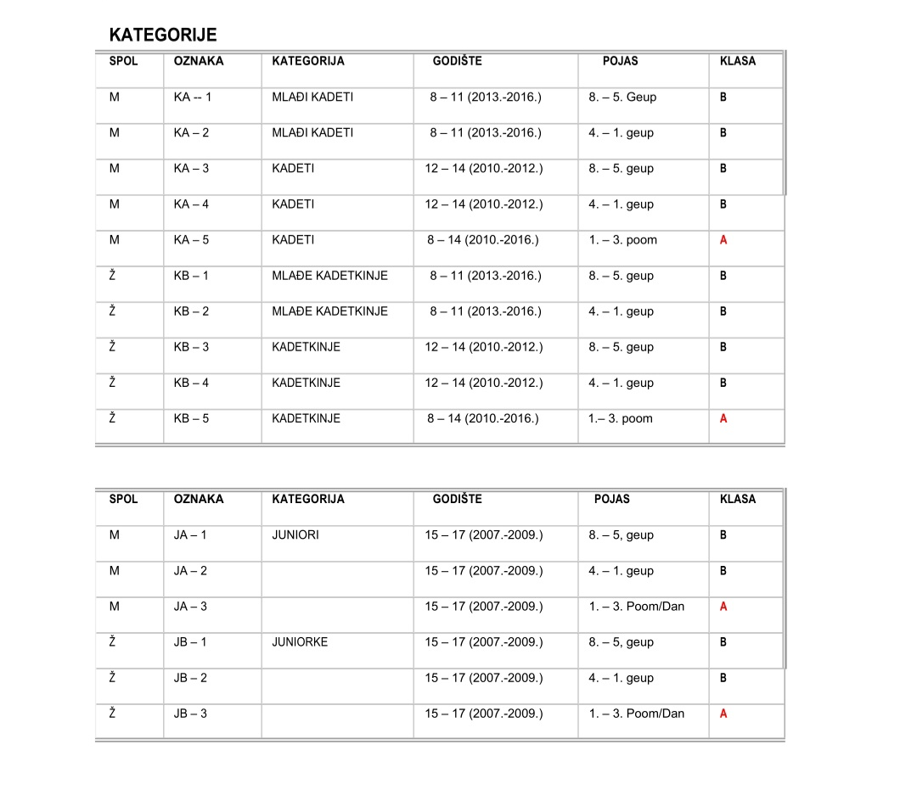
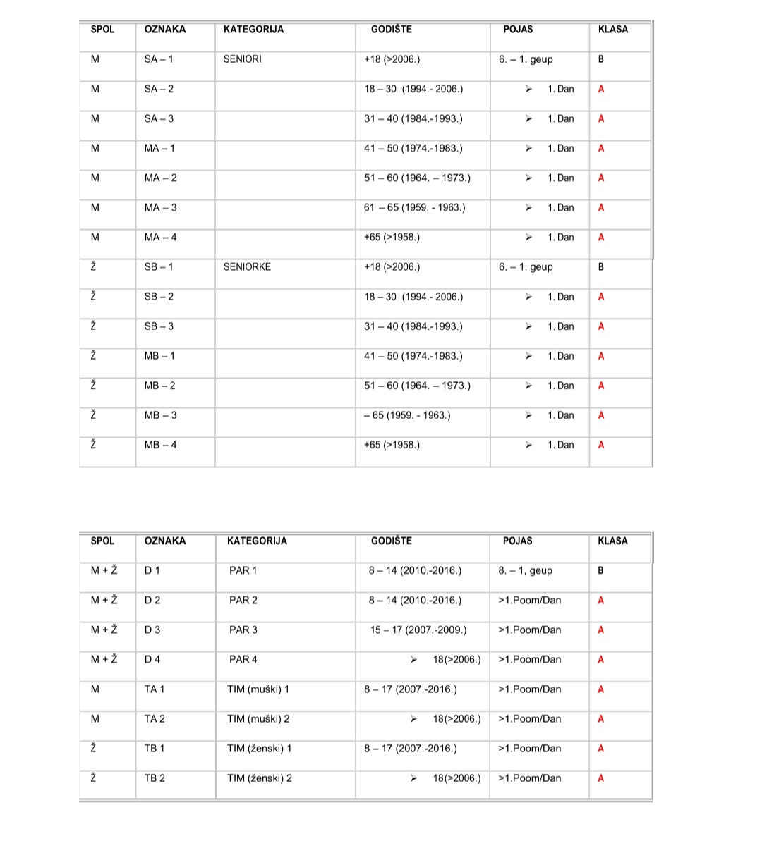
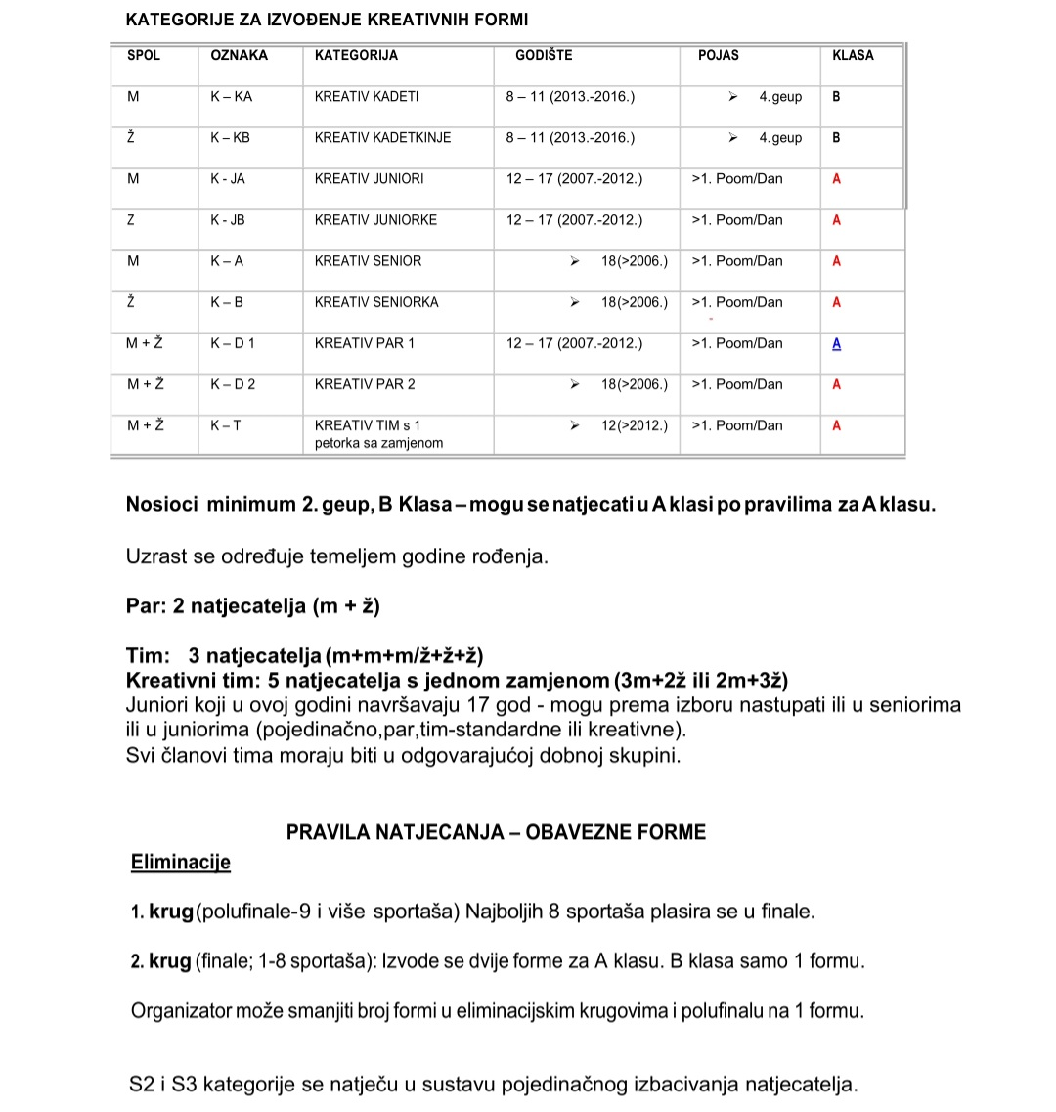
Age is determined based on the year of birth.
Pair: 2 competitors (m + f)
Team: 3 competitors (m+m+m/f+f+f)
Creative team: 5 competitors with one substitution (3m+2f or 2m+3f)
Juniors who turn 17 this year - can choose to perform in the seniors
and in juniors (individual, pair, team-standard or creative).
All team members must be in the appropriate age group.

COMPETITION RULES - MANDATORY FORMS:
Eliminations
1st round (semifinals-9 and more athletes) The best 8 athletes advance to the finals.
2nd round (final; 1-8 athletes): two forms for A class are conducted. B class only 1 form
The organizer can reduce the number of forms in the elimination rounds and semi-finals to 1 form.
S2 and S3 categories are contested in the system of individual elimination of competitors

Music for creative forms
Competitors must send music to mirjana.brezan@gmail.com
Technique: Each performance must contain attack and defense techniques (60% foot and 40% hand

