20. INTERNATIONAL TAEKWONDO TOURNAMENT
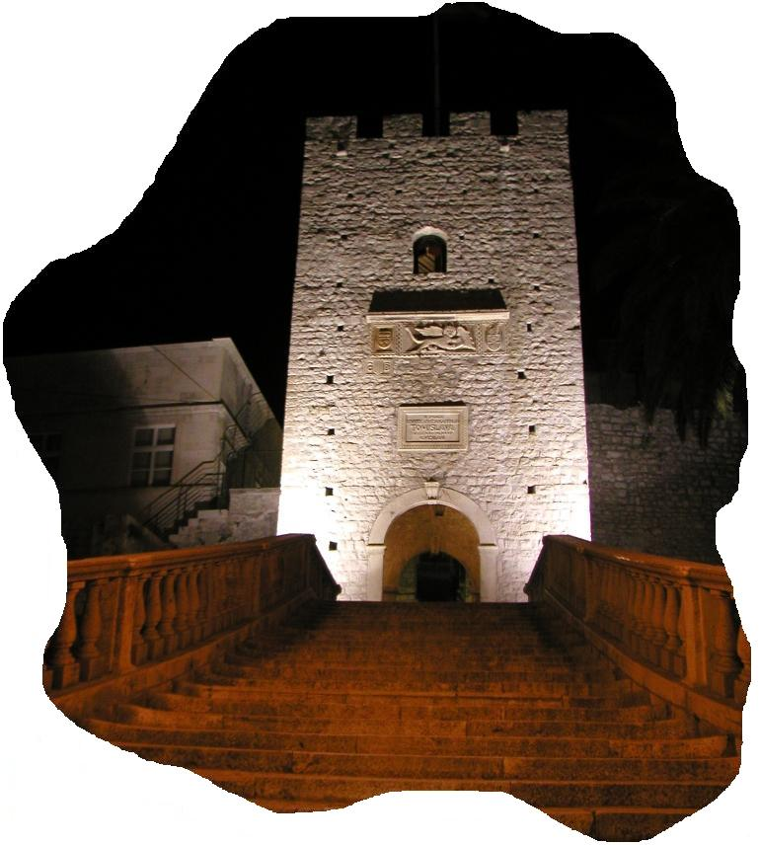
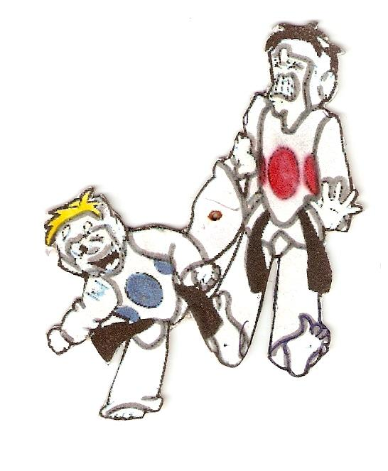
FOR CADETS,JUNIORS and SENIORS OLYMPIC CATEGORIES and POOMSE
KORČULA OPEN
2019
AWARDS
MEDALS AND TROPHY FOR 1.,2.and 3. PLACE
TROPHY FOR BEST FIGHTERS
TEAM TROPHY FOR 1.,2., and 3. PLACE

ADMISSION FEE
25 EURO FOR EACH COMPETITORS Kyorugi -25 eura
Poomse -25 eura
Kick-15 eura
K/P – 35 eura
APLICATION SUBMIT
WEDNESDAY, 21.08.2019. – 24:00 h
APPLICATION BY ONLINE:
www.taekwondo.com.hr
CONTACT PERSON: Jurica Kolaric +385915874492

For all other inquiries please contact us at:
CONTACT:
Mr.DINKO SEGEDIN
+385955270039
E-MAIL:
tkdforteca@gmail.com

CONTACT PERSON FOR ACCOMMODATION:
Mrs. RUZICA SILIC , +385 20 726 485
E-MAIL: ruzica.silic@korcula-hotels.com

NOTE:
ORGANIZER WILL INVITE REFEREES WITH
SPECIAL INVITATION

EVERY TEAM CAN SIGN UNLIMITED NUMBER
OF COMPETITORS.ORGANIZER IS NOT RESPONSIBLE FOR ANY DAMAGES,INJURIES OR LOSS. EVERY COMPETITOR IS COMPETING ON HIS OWN RISK.

ORGANIZER
TAEKWONDO KLUB „FORTECA“ KORČULA
SPONSORS
CITY OF KORČULA
H.T.P. KORČULA
TOWN SPORTS SOCIETY
DATE AND PLACE
24. and 25. AUGUST 2019.
OUTDOOR ARENA IN THE CENTRE OF THE TOWN
FRIDAY
17:00 – 20:00 WEIGHT-IN
SATURDAY:
08:30 – 14:30 QUALIFICATIONS FIGHTS
14:30 – 17:00 PAUSE
17:00 – 19:30 SEMIFINALS
19:30 – 22:00 FINAL FIGHTS AND WINER AWARDS
SUNDAY:
SAME SCHEDULE AS DAY BEFORE
RULES AND PROPOSITIONS:
WT/HTS
SENIOR MALE-OLYMPIC CATEGORIES (17 years and older)
-58,-68,-80,+80 kg
SENIOR FEMALE-OLYMPIC CATEGORIES (17 years and older)
-49,-57,-67,+67 kg
JUNIORS/MALE-2002.,2003.,2004.
-45,-48,-51,-55,-59,-63,-68,-73,-78,+78 kg
JUNIORS/FEMALE-2002.,2003.,2004.
-42,-44,-46,-49,-52,-55,-59,-63,-68,+68 kg
CADETS/male-2005.,2006.,2007.
-33,-37,-41,-45,-49,-53,-57,-61,-65,+65 kg
CADETS/female-2005.,2006.,2007.
-29,-33,-37,-41,-44,-47,-51,-55,-59,+59 kg
MODIFICATED CATEGORIES FOR CADETS (male and female)
2008.,2009.,2010. (fighting without kicking in the head)
-24,-27,-30,-33,-36,-39,-43,-47,-51,+51 kg
LITTLE OLIMPIC
GROUP A (2011. i 2012.)
-18, -20, -22, -24, -26, -28, -30, -33,-36, +36 kg
GROUP B (2013. i 2014.)
-16-18, -20, - 22, -24, -26, -28, -30, -33, +33 kg

M4 (2010/2011)

KICK:
M1 (2008/ 2009), M2 (2010/2011) i M3 (2012/2013)
F1 (2008 /2009), F2 (2010/2011) i F3 (2012/2013)

IMPORTANT NOTES:
- COMPETITION WILL BE HOLD ON 2 FIGHTING AREA AND ELECTRONIC BODY AND HEAD
PROTECTORS WILL BE USED.

